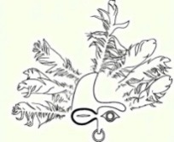
Sheldon Jackson Museum
2024 Alaska Native Artist Residency Program
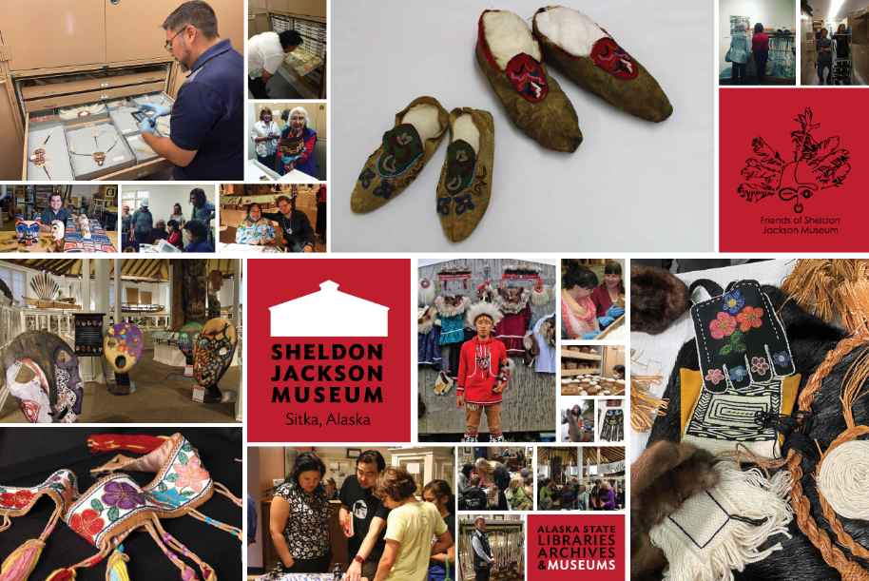

Accepting Applications from Alaska Native Artists
Five Residencies Available
$2000 salary, travel, lodging, and food stipend
June 10-July 2nd

July 29-August 18th

August 19-September 8th

September 12-October 2nd

October 3-October 24th

To apply and for details, contact Curator Jacqueline Hamberg at Jacqueline.Fernandez-Hamberg@Alaska.gov or visit http://friendsofsjm.com/NARP.php or call (907) 747-8981
Must apply by Jan. 15, 2024

