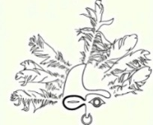
Sheldon Jackson Museum
2023 Native Artist Residency Program
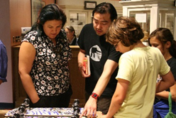
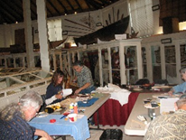
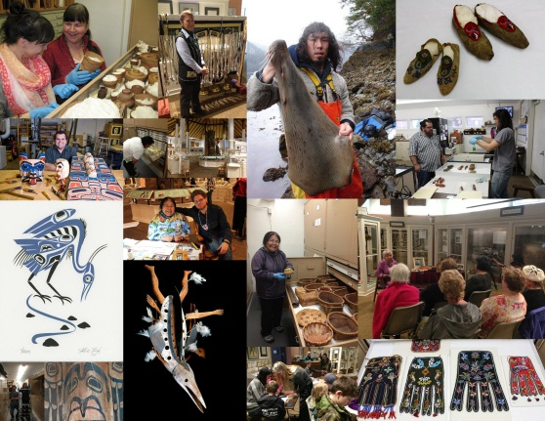

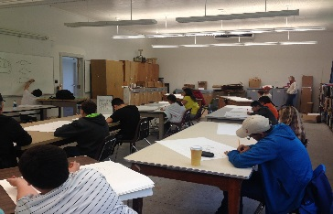
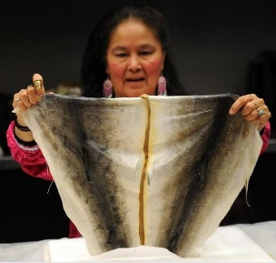

Expectations of Artists
The purpose of the artist residency program is to enable artists to create their art and engage with museum visitors and the community of Sitka. This is done as artists work on their artwork at a table set up in the museum gallery and through talks or presentations or hands-on classes given to the community in the museum gallery (or other locations if arranged with us in advance). While in residence, some artists work on multiple projects, while others work only on a single larger project.

Artists’ Schedule
Artists work in the museum in the gallery or in another public area. This residency includes a $2000 Artist Award, travel, lodging, and food per diem and involves working approximately 75 hours at the museum.
For 2023, there are four artist residency slots available:
July 7 - July 28th
August 18 – September 9th
September 15-October 6th
October 7 – October 28th
All artists have 4 hours of pre-scheduled paid Research Time in the museum office and/or in collections storage. During the 4 hours, artists have an opportunity to provide cultural consultations and share knowledge about the artifacts on exhibit and in collections storage with staff. With the artist-in-residence’s permission, their comments about artifacts and cultural belongings are added to museum records and files for future researchers, scholars, staff, and the general public to access. The museum is extremely grateful to culture bearers for their knowledge.
Artists’ Work Space and Hours/ Days Artists Can Access the Work Space
Artists working at the museum will work in a very public setting – either in the gallery or in a lobby area. The spaces are not enclosed. The museum will work with the artist to ensure a comfortable setup with good lighting, tables, power tools, if applicable, etc. The museum work space is only accessible during museum operating hours – the museum operating hours are usually daily 9:00am-5pm, though hours for the June-October period are not usually set until May and may change. Artist work space will not be accessible during non-operating hours. Artist’ days off from the museum are typically Sunday and Monday, but the artist schedule will not be set until as late as late June 2023.

Artists’ Research Time
Scheduled generally from 9-10am or at another time if arranged with curator. The 9-10am blocks of time are not listed on the publicly printed program calendar to allow for uninterrupted time in museum storage, the gallery, or museum offices. This is also a good time to prepare for any proposed classes or museum talks.

Artists-in-Residence Salary
Artists in residencies are provided with an artist award of $2,000 and are provided with travel to and from Sitka, lodging, and a stipend of $660 to offset food costs.

Payment dates will be listed on the calendar distributed to artists in June. Generally, artists are paid via check and are issued half of the stipend at the beginning of the residency and the second half at the end. Please note that your bank may not be in Sitka. You may want to plan to deposit your check via post or mobile deposit using a smartphone.

Travel
Travel will be paid for by the Friends of the Sheldon Jackson Museum. If an artist has the option of travelling by ferry or airplane, the museum will pay for whichever option is less costly. If travelling with a car on the ferry, the artist must pay for the transport of the car to and from Sitka. If an artist chooses to extend their stay in Sitka, they must make their own arrangements and pay any associated fees. If an artist misses a flight or ferry ride, they will be responsible for associated fees.

Pick-up and Drop-Off at Ferry Terminal or Airport
A representative of Friends of Sheldon Jackson Museum or museum staff will pick up the artist from the ferry terminal or airport. In some rare cases, artists may need take a taxi - in this instance, the artist will pay, provide a copy of the receipt to the museum, and then be reimbursed by the museum. Arrangements will be made in advance of arrival.

Lodging and Facilities
Artists selected for the Residency Program who do not reside in Sitka are housed in a local hotel or on the Sitka Fine Arts Campus where housing is on par with a private room in a hostel. Some residents will have access to a kitchenette and/or a coffee pot and laundry facility; some lodging will not have a kitchenette. Artist are, however, in walking distance of many dining options in the downtown area. If housed in a hotel, artists may need to walk up to 15 minutes to arrive to the museum.

Artist’s Talks and Hands-on Class(es)
Artists who propose lectures/talks or hands-on classes in their application are given preference as applicants.

Artists are strongly encouraged to give 3 talks and a hands on class teaching an art form.

The three talks should focus on:
1) the artist’s art form and cultural background

2) a selection of 2-4 artifacts in the museum’s permanent collection – how does it inspire your work, thoughts on the design and use, etc.

3) a talk on a subject of your choosing – this may be an artist’s reflection on the history of Sheldon Jackson Museum, Sheldon Jackson as a collector, reflections on the history of the Sheldon Jackson Campus and specifically, Sitka Industrial Training School and Sheldon Jackson’s connection to that boarding school or subjects such as decolonization, cultural appropriation, etc. Artists may also opt to give a Recap Talk to share their experiences at the museum and in Sitka in general and show what they created while here. We welcome proposals for talks on a variety of subjects.

The application requires a 4-5 sentence description of the talks proposed and a title of the talk. The talk may be accompanied by a PowerPoint. Copies of Power Points, if used, must be provided to the curator via email in a pptx format prior to arrival to Sitka for uploading and technical needs. To show the PowerPoint, you will need to use a museum laptop.

If an artist wants to propose a different activity such as a dance or drumming session or performance, reading, or any other creative suggestion, we welcome your ideas. Talks and classes happen in the museum gallery.

Artists’ Classes
Artists are strongly encouraged to teach their art form in hands-on classes. The application requires artists to describe specific details about age ranges of students, numbers of students allowed, materials required for students and how students can obtain them (specific pricing and link, lists, company contact info, etc. or cost of artist-prepared packet is required if artist will gather materials and charge students.) Classes can be anywhere from 1-hour on 1-day to multiple sessions over multiple days of time. A total number of hours needed to teach a class and set-up information such as number of chairs, tables, bowls of water, sinks, etc. are also required in the application. You must be as specific as possible when providing these details in your application.
Sale of Artwork
Artists in residence are not allowed to sell their artwork directly to museum visitors in the gallery or on museum grounds. The museum does, however, encourage artists to have business cards, contact information, binders or portfolios showing examples of art, etc. with them while they are working at the museum to show visitors.

What if I need something? What if I am late? Lost? Miss my flight/ferry? Unhappy about something? What is the best place to eat in town? What restaurant should I order delivery from? What if……..?
Our goal is to make you welcome and comfortable. The Friends of Sheldon Jackson Museum and museum staff are here to help you. If you need anything or have any issues, please alert us by talking to staff in person. You may call the museum directly at (907) 747-8981, or for emergencies, call museum curator Jackie Hamberg at (781) 738-7510. If the issue is related to lodging (loss of a hotel key, etc.), you will need to contact the front desk of your lodging. If you are running late to work or are going to be out sick, please call the museum directly to let staff know at (907) 747-8981.

