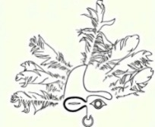
Sheldon Jackson Museum
2023 Alaska Native Artist Residency Program
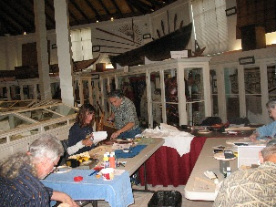
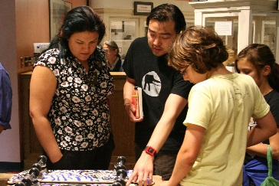
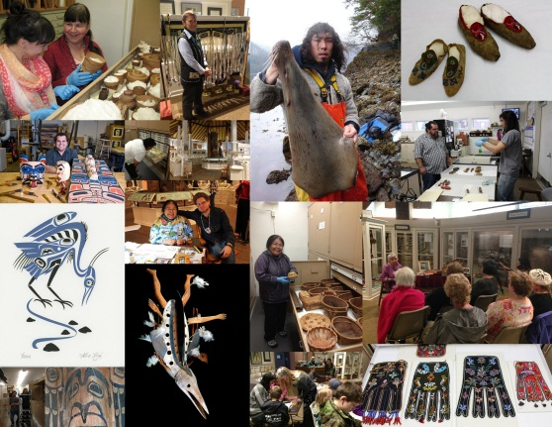

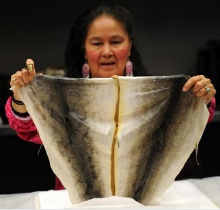
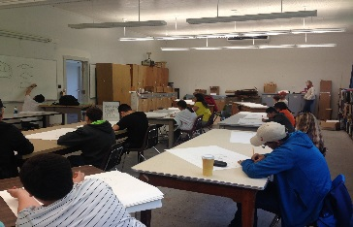

Accepting Applications from Alaska Native Artists
Four Residencies Available
$2000 salary, travel, lodging, and food stipend
July 7-July 28th

August 18–September 9th

September 15-October 6th

October 7-October 28th

To apply and for details, contact Curator Jacqueline Hamberg at Jacqueline.Fernandez-Hamberg@Alaska.gov or visit http://friendsofsjm.com/NARP.php or call (907) 747-8981.
Must apply by Dec. 22, 2022

